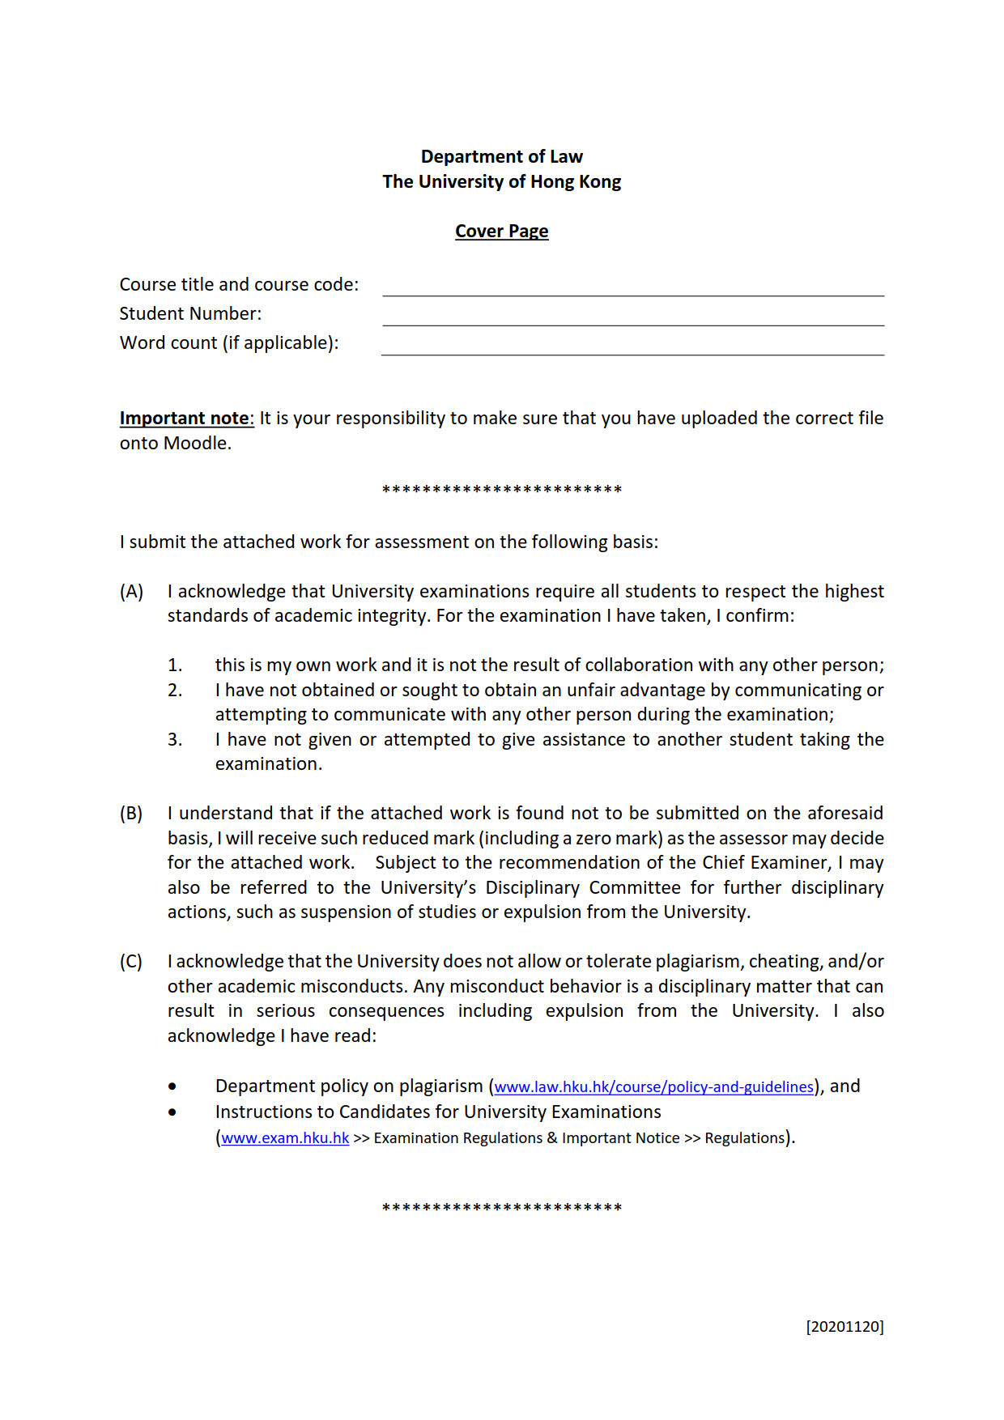

|  |  |
| --- | --- |
| **Course title and course code:** |  |
| **Student Number:** |  |
| **Word count (if applicable):** |  |

